**PREDICTING HEART FAILURE**

**USING IBM AUTO AI SERVICE**

**PROJECT REPORT**

**SUBMITTED BY:**

**AYUSHI JAR**

**MARCH,2020**

**1. INTRODUCTION:**

1.1 OVERVIEW

Cardiovascular diseases (Heart related diseases) are the most common leading cause of death over the few years. There are several factors for causing heart disease such as unhealthy diet, lack of physical exercise, smoking or drug usage, alcohol contribute to social problems (see **APPENDIX** for gobal risk factors). Some of the risk factors that cannot be determined such as family background and age factor.

Here in this project, we will use IBM Auto AI service to make a web based application that predicts the heart failure by training the model by giving medical dataset . The application of algorithms and interpretation of the patterns used in machine learning can be helpful in saving numerous people lives by anticipating the condition of the disease in advance. This project is focused on determining whether the patient has a heart disease or not by taking into consideration the following attributes:

|  |  |  |
| --- | --- | --- |
| **S no.** | **Attributes** | **Values** |
| 1. | Average heart beat per minute | continuous value |
| 2. | Palpitation per day | continuous value |
| 3. | Cholestrol | continuous value in mg/dl |
| 4. | BMI | continuous value in kg/m2 |
| 5. | AGE | continuous value |
| 6. | SEX | Male = M  Female = F |
| 7. | Family history | NO = N  YES = Y |
| 8. | Smoking last 5 years | NO = N  YES = Y |
| 9. | Exercise minutes per week | continuous value |

1.2 PURPOSE

The main purpose is to develop a heart disease prediction web application which is GUI-based, user-friendly, scalable, reliable and an expandable system that predicts whether a patient is suffering from heart disease or not by simply giving inputs like age, gender, smoking, exercise time period etc. It is developed by using following IBM services :

1. IBM Watson Studio
2. IBM Watson Machine Learning
3. Node-RED
4. IBM Cloud Object Storage

**2. LITERATURE SURVEY:**

2.1 EXISTING PROBLEMS

Healthcare decisions are often made based on doctors’ intuition and experience rather than on the knowledge rich data hidden in the data set and databases. This practice leads to unwanted biases, errors and excessive medical costs which affects the quality of service provided to patients.

Moreover, the disease may remain untreated and become serious issue (in some cases) due to human errors and inexperience of medical staff. This may also lead to high cost for surgical treatment, medication and other expenses.

2.2 PROPOSED SOLUTION

Heart diseases can be managed effectively with a combination of lifestyle changes, medicine and, in some cases, surgery. With the right prediction of heart failure , the chances of heart disease can be reduced by taking proper actions and the functioning of the heart can be improved. The predicted results can be used to prevent and thus reduce cost for surgical treatment and other expenses.

The overall objective of this work will be to predict accurately with few tests and attributes, the presence of heart disease. Attributes considered form the primary basis for tests and give

accurate results more or less.Our goal is to make a web application to predict with few attributes and faster efficiency the risk of having heart disease.

**3.THEORETICAL ANALYSIS**

3.1 BLOCK DIAGRAM

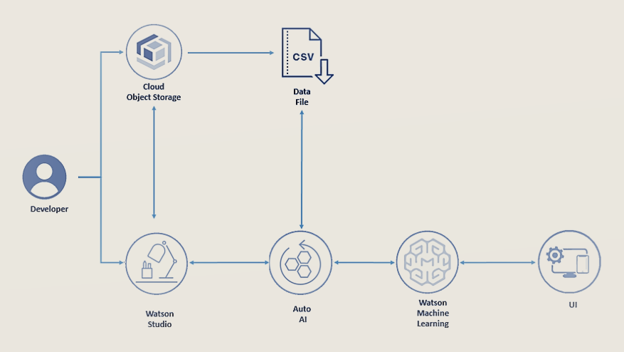

3.2 HARDWARE /SOFTWARE DESIGNING

**Software Requirements**:

1) Operating System : Any OS with clients to access the

internet

2) Network: Wi-Fi Internet or cellular Network

3) Browser: Medium to open IBM cloud and other websites.

**4.FLOW CHART**

START

Collection of data set for prediction process

Apply the data preprocessing techniques

Apply the support vector machine Algorithm to predict

Disease prediction

Patient have heart disease

Patient does not have heart disease

**5. RESULT:**

***MODEL LINK:***

***<https://node-red-aalhh-2021-03-18.eu-gb.mybluemix.net/ui>***

***OUTPUT AFTER CLICKING THE MODEL LINK:***

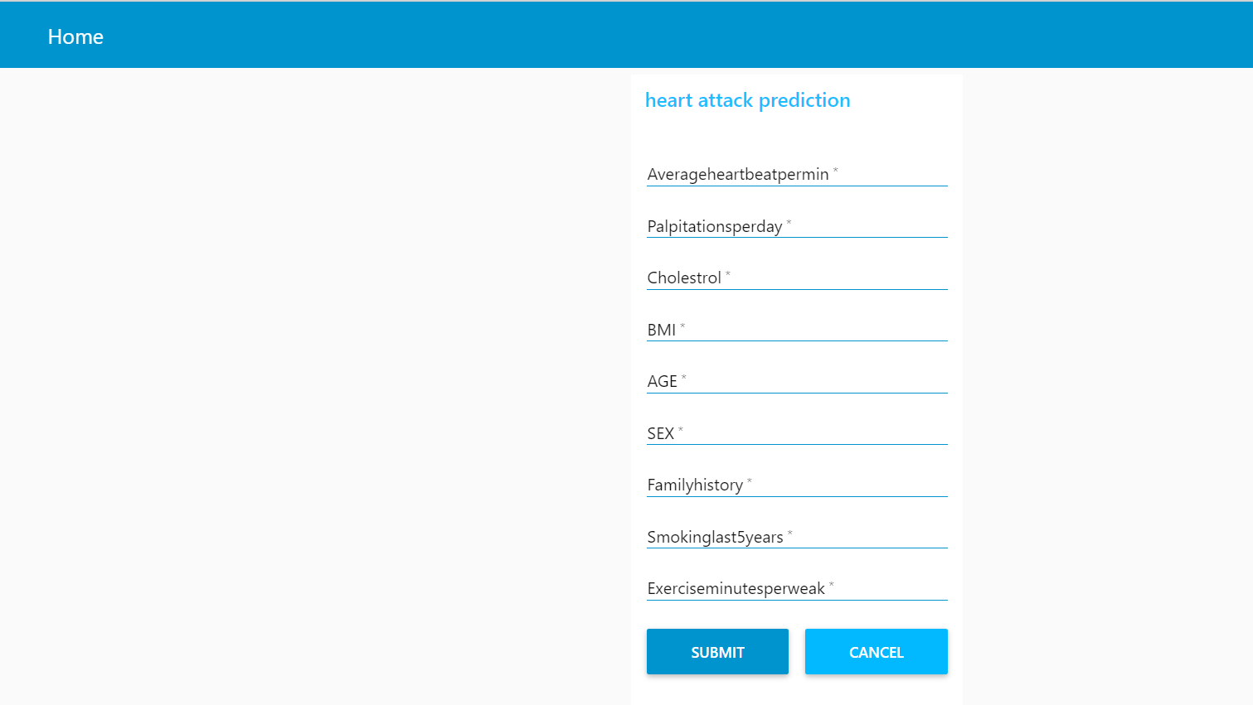

***OUTPUT AFTER FILLING THE REQUIRED ATTRIBUTES:***

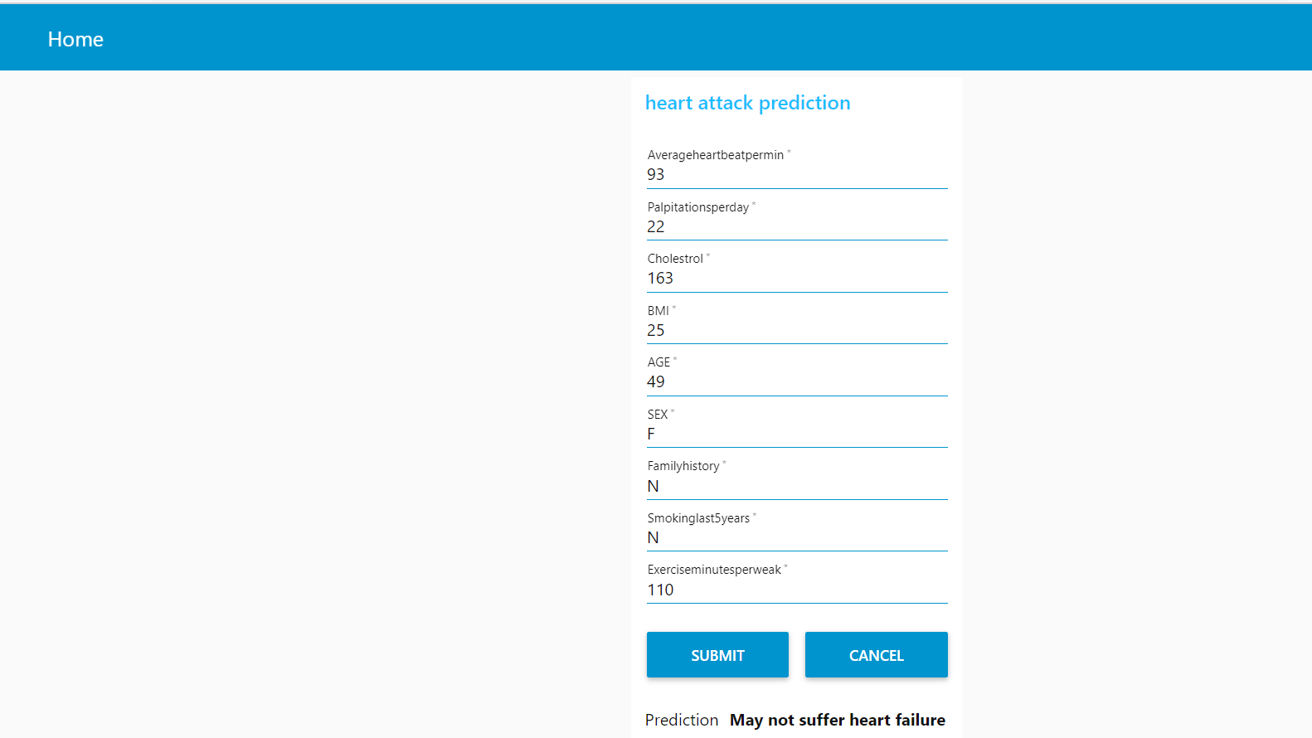

**6. ADVANTAGES :**

1.This will reduce medical errors and enhance patient safety.

2. It decreases the unwanted practice variation, and improves patient outcome.

3. Data modeling and analysis tools used in this project , e.g., data mining, have the potential to generate a knowledge rich environment which can help to significantly improve the quality of clinical decisions.

4.AI contributes to medical business intelligence which is useful for diagnosing of disease and taking action accordingly.Moreover it is cost effective, less time consuming, can be used anywhere and free from errors during checkup and medical practitioning.

5.It can be used anywhere with proper internet connection.

6. it Reduces the overall time complexity of doctors.

**DISADVANTAGES**

1.. Heart failure Predictor does not recommend medications of the disease.

2.Also it do not recommend possible changes in life style or action which can help to improve the heart condition.

3. Past history of the disease has not been considered by this application.

4.The discrimination and range of prediction are likely affected by several limitations of the data set.

5.The interpretation of the results can be varied depending on the particular data set and purpose of modeling.hence It may give different outcome depending upon the dataset given during the making of application for the same case.

6.There may be some measurable domains of variables which are not analyzed in this IBM Auto AI service that might be more predictive in all patients with heart failure.

**7. APPLICATION**

1. It has vast application as a cost effective, less time consuming and efficient health care model.

2. The model can serve the purpose of training tool for medical students .

3. It can also be used as soft diagnostic tool available for physician and cardiologist.

**8. CONCLUTION**

In this project, we developed and concentrated on heart failure predicting web Application. Using machine learning techniques, the heart disease can be predicted. The medical data such as Average heart beat, smoking, family history ,BMI, Cholestrol and so on is taken as input and then these features are modelled for prediction. This model is user friendly, cost effective, increases efficiency and give result in less time. Moreover it has large future scope and can be used in various ways after positive changes and advancement.

**9. FUTURE SCOPE**

As we have developed a generalized system, In future we can use this system for the analysis of different data sets. The performance of the health’s diagnosis can be improved significantly , and it can be another positive direction of research. In DM warehouse, generally, the dimensionality of the heart database is high, so identification and selection of significant attributes for better diagnosis of heart disease are very challenging tasks for future research. Also Future work needs to focus on further improvement of predictive ability through advanced methods and more discerning data, so as to facilitate better targeting of interventions to subgroups of patients at highest risk for adverse outcomes.

**10. BIBILOGRAPHY**

A.Davis, D., V.Chawla, N., Blumm, N., Christakis, N., & Barbasi, A. L. (2008). Predicting Individual Disease Risk Based On Medical History. Adam, S., & Parveen, A. (2012)

JyotiSoni, Ansari, U., Sharma, D., & Soni, S. (2011). Predictive Data Mining for Medical Diagnosis: An Overview Of Heart Disease Prediction.

Purushottam, Saxena, K., & Sharma, R. (2016). Efficient Heart Disease Prediction System. In Procedia Computer Science (Vol. 85, pp. 962–969). https://doi.org/10.1016/j.procs.2016.05.288

Science, C., & Faculty, G. M. (2009). Heart Disease Prediction Using Machine learning and Data Mining Technique. Ijcsc 0973-7391, 7, 1–9.

NisharBanu, MA; Gomathy, B;. (2013). Disease Predicting System Using Data Mining Techniques

**APPENDIX**

RISK FACTORS OF HEART DISEASES

